PLANNING

We are investigating …
______________________________________
______________________________________

We could change  ☑☒  - ◻  - ◻  - ◻  - ◻  - ◻  (tick the one you will investigate) | We could measure /observe  ☑☒  - ◻  - ◻  - ◻  - ◻  (tick the one you will measure/observe)

Our question is …

How does the _____________ affect the ______________?

We will change …  __________________  (the input or independent variable) | We will measure/observe…  ____________________  (the outcome or dependent variable)

We will keep these the same How I will control them
(control variables to make it a fair test) value
- ___________________ __________________ ( )
- ___________________ __________________ ( )
- ___________________ __________________ ( )
- ___________________ __________________ ( )
- ___________________ __________________ ( )

PREDICTION

When we increase/change the ______________________ we think

that the _____________________ will ______________________

OR

The _________________er the _____________________, the

___________________er the ______________________

Key Words

Explanation (use the Key Words and science words that you know)

This is because ....

RESULTS

Change…  (independent variable) | Measure …  (dependent variable)
⬇ | ⬇
( ) | ( )
 |  |  |  | Mean

GRAPH

My graph to show how the ________________

changes when we change the __________________

_____________ ( )
outcome or dependent variable
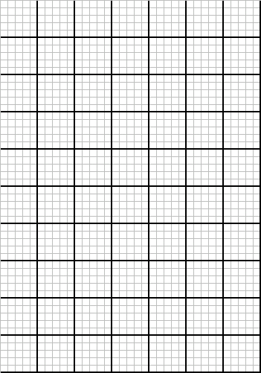

_____________ ( )
input or independent variable

CONCLUSION

From my graph we can see that when we increased/changed

the __________________ the ________________

and/or

The _________________er the ____________________, the

__________________er the _____________________

MY GRAPH:

The shape of my line graph is :

a straight line a curve

Pattern :

(Explain what your graph shows as scientifically as you can)
__________________________________________________________________________________________________________________________________________________________________________________________________________________
___________________________________

Was your prediction correct? Yes No

EVALUATION

Were there any anomalous (unusual) results? Yes

No

If yes, which result(s)? ___________________________________________
___________________________________________

Why do you think this happened?

How could you have improved your method to make your results more reliable ?

What, if anything, could you do next ?

